Ryan PAC Meeting
Wednesday March 11, 2020
Attendance
Erin Claycomb Co-Chair, Christine Paquette Co-Chair, Deborah Contardi Treasurer, Bridget Garabedian Secretary, Judy McInnis Principal, Nicole Zwierk Teacher, Rob Rodgers Teacher
Members – Attendance list kept with Co-Chairs, not distributed with minutes
Meeting held at the Ryan School in the Teachers’ lounge
Welcome
@ 6:35 Christine Paquette welcomed everyone to the PAC meeting - with introductions.
Minutes from January unable to print will send out to members or approve at next meeting.

Financial Report- Deb Contardi
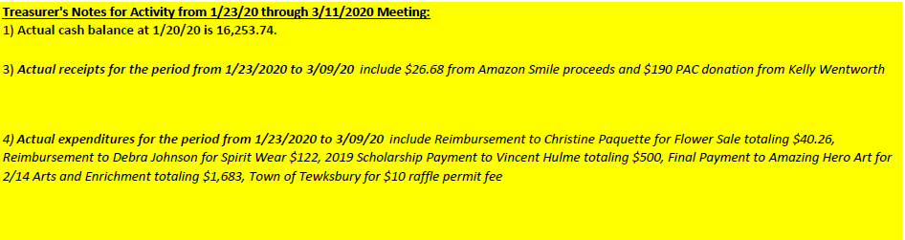

Names drawn from bowl with all scholarship applicants, 2- $500 scholarships awarded from the PAC.
Christina Johnson and Arya Mehrabani chosen and will be notified, will update the High School.

Principals Report – Principal Judy McInnis
Step it Up was denied fundraiser, PAC will reach out for clarification regarding future programs and understanding of concerns with this program. Bus loop will be earmarked for recess area. Plan is to shut down daily during recess time for recess use. Exploring options for kids to use indoor Gymnasium or outdoor bus loop space. Thank you to the team taking care of the front of the building, with flower planters being updated regularly, building looks great. Update on Coronavirus and school and district news regarding current state of management. Ms. McInnis welcoming questions and input, expressed hopes parents will reach out with any and all concerns.

Sub Committee Updates/Upcoming Events
- Book Fair – Bridget Garabedian
  - April 3-9th, discussed $310 Scholastic dollars to expire, proposed $1000 Scholastic dollars to donate to teachers/cultural books for library as staff requests
- Stop and Shop – Paige Impink
- Arts & Enrichment – Bridget Garabedian and Tania Sullivan Hero Art Feb 14th, whole school 5th and 6th grades separate sessions. Very well received. Donated Wonder Woman art donated, will seek donation for item for raffle.

- Green Team – Gina and Heidi
  - Tree is secure, will be returned to PAC room

On Going
- Box Tops- Kristi Palma
  - Grades are in competition for collection, digital scanning is not a successful as the cut box tops. Will ask for morning announcements to include box tops. Extra sheets in the office for dimes.

Looking Ahead
- Food Truck Festival- Erin Claycomb
  - Approved to have event at Wynn 4/21, unsure of time possibly 5pm start. Use loop area, near to gym area and grass for demonstrations. BOH clearance received. Hearing back from several trucks, Cluck Truck, Shawsheen Tech, Kona Ice, Wicked Cheesy, awaiting several call backs. Jamaican me Hungry, Empanada Data.
  - DJ needed. One person offered to help for $200. Known DJ. Consideration to purchase equipment
  - ATA martial arts and Dance Expressions may participate again
  - Wicked Corn hole supplies were unsupervised last year, this year identified two parents to supervise. Wicked Corn hole will allow use of mini corn hole boards.
  - Will circulate flyer once all is confirmed.
- Calendar Raffle - Julie Naughton
  - Raffle Is circulating. Names will be pulled every day in April.
- Teacher Appreciation
  - Luncheon, possibly luau style.
  - Flower Sales, Jen Insognia will run flower sales Monday of that week.
- Cultural day – School Program- in discussion possibly held during ISTEM night, teachers and parents met today, if other members are interested please reach out to join the committee
- Career day- Jen Stanton and Erin Claycomb
  - Date needed. Same format as last year. Lots of positive feedback on how event ran last year. 9-1130 ran last year.
  - May 6th tentative date for event this year.
- Ryan PAC for year 2020-2021 – looking ahead for next year for committees and PAC leadership
  - Any interest in co-chair positions, still seeking

MCAS dates:
4/14 ELA MCAS Grades 5&6
4/15 ELA MCAS Grades 5&6
5/12 Math MCAS Grades 5&6
5/13 Math MCAS Grades 5&6
5/18 STE MCAS Grade 5 only
5/19 STE MCAS Grade 5 only

Questions/Comments
Adjournment @

