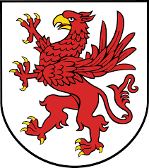
WYNN PAC AGENDA
WEDNESDAY MARCH 21, 2018
•Welcome
•Review November 2017 Minutes
•Principal’s Report
•Treasurer’s Report
•By-Law Vote
•Elections for Officers for 2018/2019
•Sub Committees
- BoxTops
- Spinner’s Baseball Game
- Arts and Enrichment
- Hospitality
- Teacher Appreciation Luncheon
- Book Fair
- Golf Tournament/ Other Event
•Questions
•Adjournment
Next PAC Meeting: Wednesday, May 16, 2018

