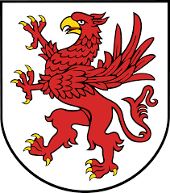
WYNN PAC AGENDA
MONDAY, NOVEMBER 13, 2017
•Welcome
•Review September 2017 Minutes
•Principal’s Report
•Treasurer’s Report
•Yankee Candle/ Spirit Cup Fundraiser
•Sub Committees
- Boxtops
- Arts and Enrichment
- Coats for Kids
- Hospitality
- Riverhawk Hockey Game
•Questions
•Adjournment
Next PAC Meeting: Wednesday, January 17, 2018

