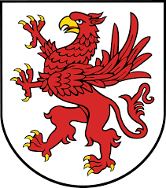
WYNN PAC AGENDA
WEDNESDAY SEPTEMBER 20, 2017
•Welcome
•Review June 2017 Minutes
•Principal’s Report
•Treasurer’s Report
•Yankee Candle/ Spirit Cup Fundraiser
•Sub Committees
- Boxtops
- Arts and Enrichment
- Coats for Kids
- Hospitality
•Questions
•Adjournment
Next PAC Meeting: Monday, November 13, 6:30pm

