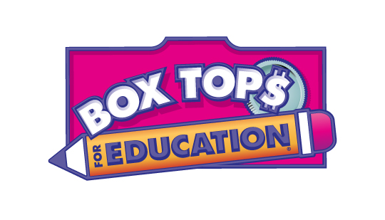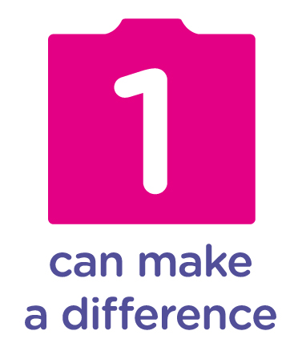

Dear Parents and Guardians,

My name is Monica Johnson and I am the volunteer Box Tops coordinator at the Loella F. Dewing Elementary School for the 2013-2014 school year. Box Tops is all about the difference 1 person can make.

Box Tops are little coupons found on everyday items such as Ziploc bags, Betty Crocker frosting, Pillsbury rolls and General Mills cereal to name a few. Each one of these coupons is worth ten cents; which really adds up! You and your child will be amazed how quickly those little coupons turn into dollars to help purchase books, materials, and equipment for our school!

Here are the easy, everyday ways you can help:

Clip — Clip the Box Top from hundreds of participating products and send them to school. Each one is worth 10¢ when our school redeems them from Box Tops for Education. You can use a Ziploc collection bag to hold those Box Tops; bags can be kept on the refrigerator or in a kitchen drawer.

Sign up Online –– It’s easy and free. Sign up to support our school at btfe.com, where you can:

• See how much our school is earning with Box Tops
• Enter online promotions for chances to win Bonus Box Tops and other prizes
• Print money-saving coupons for your favorite Box Tops brands
• Make mealtime easier with family-pleasing recipes

You can also sign up for Box Tops email newsletters that will keep you updated on the program, and for Marketplace newsletters with Box Tops members-only deals and discounts.

Here are a couple Box Tops Collection tips:

Check Expiration Dates -- Keep an eye on the date in the lower right corner of the Box Top. Be sure that when cutting out Box Tops, the date is visible.

No Staples, Please -- When attaching Box Tops to collection sheets, use glue or tape. Staples are not allowed in our submissions and must be removed by the Dewing volunteers before we can collect our cash….ouch!

Get Others Involved – Increase your collection by asking grandparents, relatives, childless friends, and co-workers to clip and collect Box Tops!

Contests -- Be on the lookout for contests throughout the school year. Speaking of which, in this packet, you will find your first collection sheet. Turn in this form with 25 Box Tops attached by September 19, 2014, to enter the first Preschool and Kindergarten contest of the 2014 - 2015 school year. After filling up the collection sheet, please return it to your child’s teacher in an envelope marked “Box Tops Contest.” Feel free to make copies of the contest and submit as many as you like. The more sheets you send in, the more entries your child gets into the contest.

To learn more about Box Tops, visit btfe.com—and thanks for choosing to make a difference for our school with Box Tops!

If you have any questions, please feel free to e-mail us at Dewschoolfundraising@gmail.com.

Sincerely,

Monica Johnson

Box Tops Coordinator at the Dewing School

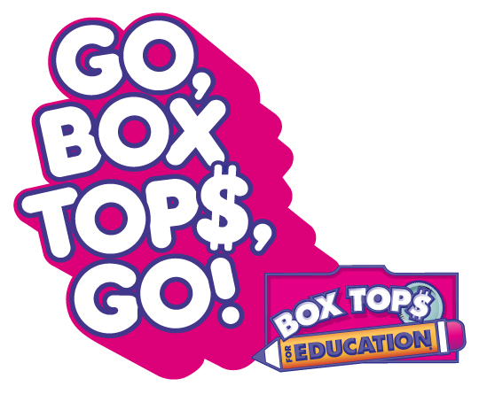get the latest at www.btfe.com

Other contests

On Facebook, Target has a promotion through September 8, 2012 on their Give With Target application. For every 25 votes the Dewing School receives, a $25 gift card will be donated to the school to be used for school supplies. Please vote and get your friends and family to vote too. No cost to you and it benefits our teachers!

Avery – Give Back to Schools – This promotion ends on September 14, 2012. You just need to log in and vote for our school. During the 2011/2012 school year, the Dewing School won $500 worth of Box Tops from this promotion. With your help, we can get there again. Vote daily and get your friends and family to vote too!

Please learn about all of our contests and other great information by following the Dewing School PAC on Facebook at “Friends of L.F. Dewing Elementary School PAC”.

